Tenda AC10U-How to setup guest network
Model Number: Tenda AC10U
Question Classification: Function Setting

Step 1: Open a browser and type http://tendawifi.com in Address Bar, tap “Enter”. Input login password and tap “Login”.

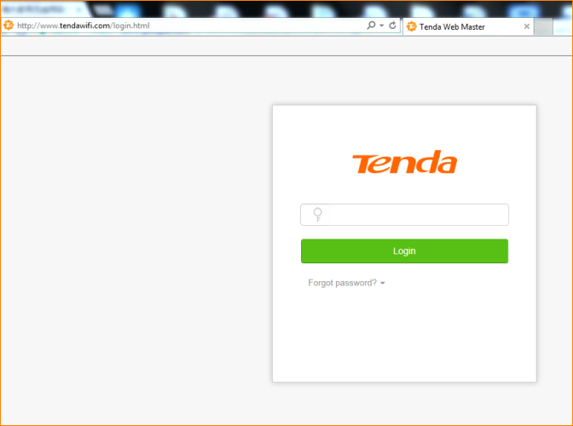

Step 2: Tap “Guest Network”, set up Name, Password, Validity and Shared Bandwidth for Guest.
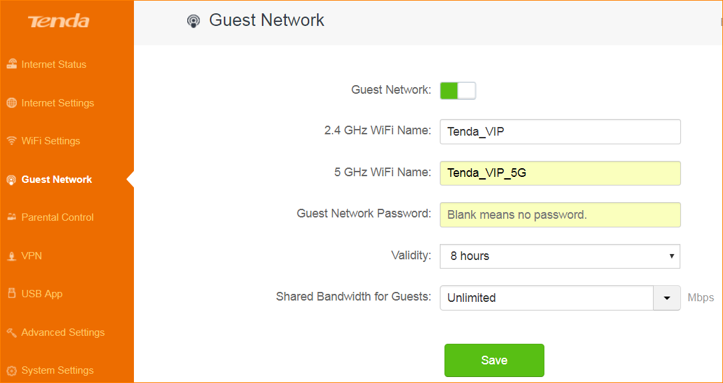

NOTE: Guest Network password: if not encrypt, please keep it empty;
Validity: default setting is 8 hours, guest network will close after 8 hours. Please select “Always” if you want to keep Guest Network open.
Shared Bandwidth for Guest: default setting is unlimited, no restriction in speed for all users. (Options: 2M, 4M, 8M, custom)

